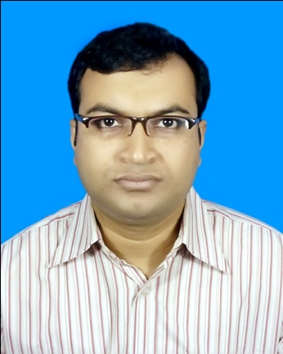
Resume of
Md. Shamsuzzaman Jubayer
+88 01717 635 204
jubayer07001@yahoo.com

CAREER OBJECTIVE

To work with a position where sincerity, dedication, strong communication, leadership skill and attention to details are essential. Looking forward to have a learning environment and the opportunity to prove potential.

JOB EXPERIENCE

Employer: Purple Telecom Limited
Designation: Engineer in Billing Department
Duration: March 18, 2014 to till now

Previous Employer: ConnectBD Limited
Attachment: Roads and Highway Department,
Government of People’s Republic of Bangladesh
Sarak Bhaban,
Ramna, Dhaka,
Bangladesh
Designation: Programmer (MIS & CMS)
Duration: February 01, 2011 to March 15, 2014
PROFESSIONAL PROJECTS

Title | : LGED Pauroshova MIS
Description: | Manage entire MIS the Pauroshova-s of Bangladesh from a central umbrella. It includes Development & Engineering, Trade Licence, Holding Tax, Water Supply & Sanitation, Health & Immunization, Planning and Tendering.
Used Tools: | C#, MS SQL, Crystal report
Project URL: | http://180.211.159.2/portalUi/

Title | : Roads and Highway MIS (http://123.49.36.101:8080/DivisionOverview.aspx)
Description: | Manage all development and maintenance activities of pave and unpaved roads in Bangladesh under RHD.
Used Tools: | C#, VB6, MS SQL, Crystal report

SKILL SET

Skill Type | Skill Name | Proficiency Level | Last Used | Length of Experience
DATABASE | Sql Server | High | Current | 4 year
DATABASE | Oracle | Moderate | Current | 3 year 6 Months
.NET Development Platform | ASP.net | High | Current | 4 Year
.NET Development Platform | VB.net | Moderate | Current | 3 year
.NET Development Platform | C#.net | High | Current | 4 Year
.NET Development Platform | MVC | Moderate | Current | 3 year
Technology Reporting Tool Language | AJAX | Moderate | Current | 3 year 6 Months
Technology Reporting Tool Language | Crystal Report | Moderate | Current | 3 year 6 Months
Technology Reporting Tool Language | VB | Moderate | Dec-2012 | 8 Months
Client Side Scripting | JavaScript | Moderate | current | 3 year 6 Months

ACADEMIC INFORMATIONS

Degree/ Examination | Institute | Major | Passing Year | CGPA/ Percentage
B. Sc. Engg. in Computer Science & Engineering | Mawlana Bhashani Science & Technology University (MBSTU) | Computer Science & Engineering | 2010 | 3.42  (out of 4.00)
H.S.C. | Bheramara College | Science | 2006 | 4.00
S.S.C. | Bheramara High School | Science | 2003 | 3.88

PUBLICATION

Md. Rashadul Hasan Rakib, Md. Shamsuzzaman Jubayer, Md. Thanvir Ahmed, Feature based Semi-Supervised Product Clustering using Weighted Word, In proceedings of IEEE/OSA/IAPR International Conference on Informatics, Electronics & Vision.

That is published in IEEE digital library.

UNDERGRADUATE THESIS

Title | Feature based Semi-Supervised Product Clustering using Weighted Word
Co-Authors: | Md. Thanvir Ahmed  Undergraduate Student
Supervisor: | Md. Rashadul Hasan,  Assistant Professor,  Dept. of Computer Science and Engineering, MBSTU
Description: | Proposing the best product cluster base on product-feature
LANGUAGE

Bengali: Mother Language
English: Good in Reading, Writing and Listening

CO-CURRICULAR ACTIVITIES

- Attended several Programming Contest events in MBSTU.
- Participated Inter Department Debating Contest in MBSTU 2009.
- Best Scout- district level, Kushtia, 2003.

PERSONAL INFORMATIONS

Name: Md. Shamsuzzaman Jubayer
Father’s Name: Md. Golam Mostafa
Mother’s Name: Mst. Sajeda Begum
Mailing Address: Flat-301
135/1 East RazaBazar
Tejgaon, Dhaka -1215,
Bangladesh
Permanent Address: Professor Para,
Post – Bheramara
District – Kushtia
Bangladesh.
Religion: Islam
Nationality: Bangladeshi
Passport Number: AC2007393
Date of Birth: 03 August, 1987
Marital Status: Married.

